CoDes Project Brief: Simply Business

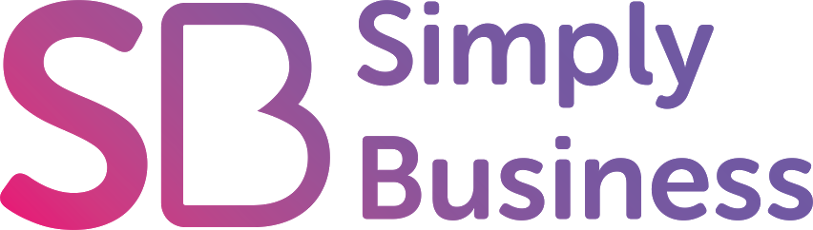

Project 1: Improving decision-quality and preventing adverse outcomes in insurance
One of greater challenges in the insurance industry is ensuring that those taking out insurance policies correctly reflect their risks in the ‘covers’ they choose. Accurate public data on (un)successful claims are difficult to obtain, as insurers are incentivised to show higher rates of successful payouts to claims. Figures suggest up to 20% of claims in insurance are rejected. Simply Business’s data shows that up to 52% of claims are rejected yearly, with the main reason(s) being inadequate/lack of cover.

The project will look at possible reasons for this (e.g. decision complexity, poor consideration of outcomes, over-attention to price etc.) that may lead to inadequate cover at point-of-purchase/decision. The student is expected to apply theories and evidence from psychology to generate hypotheses and solutions to aid decision-making, testable in an experimental and/or real-world setting.

Supervisors: Dr Keith O’ Brien (Simply Business/UCL); Dr Adam Harris (Secondary; UCL);
Project Contact: Keith O’ Brien (keith.obrien@ucl.ac.uk)

General Info:
The project will be be conducted throughout the normal April-August period, and based between UCL and the Simply Business offices in Bank. The student will be supported and given all necessary resources to support the project’s success (e.g. access to data, methods, upskilling, on-site supervision etc.)

While there are no prerequisite skills needed beyond an understanding and willingness to research in the cognitive/decision-sciences, students with strong experimental backgrounds and interest in practical applications are encouraged. Applicants are encouraged to read this article.

About Dr Keith O’ Brien:

Keith O’ Brien is the Behavioural Insight Lead at Simply Business, and Honorary Research Fellow at UCL. He received his PhD from UCL Experimental Psychology, researching voter judgment and decision-making in elections and how ‘accurate’ voters are in choosing candidates. A former Teaching Fellow in Experimental Psychology, and Assistant Director of the UCL Centre for Behaviour Change, Keith has also taught at LSE on applying behavioural science to management and public policy.

About Simply Business

Simply Business is the UK’s biggest business insurance provider, specialising in public liability insurance for SMEs and landlord insurance. It was awarded winner of The Sunday Times’ Best Company to Work For in 2015 and 2016.

Launched in 2005, Simply Business provides an online brokerage service delivering policies tailored to individual business requirements. Simply Business provides insurance to more than 430,000 UK SMEs and landlords, covering over 1,000 trade types. It employs over 400 people across offices in London (Bank) and Northampton, and is rapidly expanding offices in Boston (MA) to serve the US market of 29 million SMEs.

Revenues have grown from £4.2 million in 2006, to £25.4 million in 2014, and the company has been recently acquired by the US insurance company Travelers (Dow Jones 30; revenues of US$ 27.6 billion in 2016).

